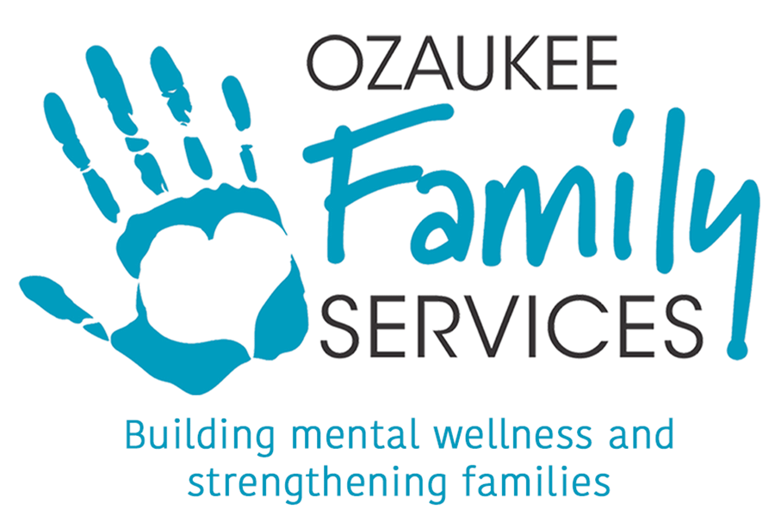

Dear Community Member,
We’re excited to announce our 5th Annual Gala, Evening of Believing, on Saturday April 25, 2026, at Shully’s Watermark in Thiensville. As our largest fundraiser, the event’s proceeds will help us continue offering free services and affordable counseling to those in need. For details, visit https://www.ozaukeefamilyservices.org/gala2026
We’d be honored if you’d consider donating an item for our silent auction. Your contribution will make a direct impact on our community.
Ozaukee Family Services, a nonprofit serving Ozaukee County since 1974, supports over 6,000 local residents each year with programs including:
- Affordable Counseling & Mental Health Services for individuals and families, especially those uninsured or underinsured.
- Parent Education & Support through home visits, workshops, and group programs.
- Prevention Education for Children covering topics like child abuse, internet safety, and eating disorders.
- Senior Services to help seniors stay independent in their homes.
Your support makes it possible for us to provide these services to all Ozaukee County residents, regardless of their ability to pay.
Please note, donations and drop-offs are due by April 15th. Please contact Erin below if you have any questions. Thank you for considering a donation to our silent auction and for helping us continue to improve lives in our community.

Sincerely,
Erin Teplin
Marketing Director, Ozaukee Family Services

